**1. Introduction**

**A. Purpose**

G1: The system should provide customers with a reasonably precise estimation of the waiting time and should alert them taking into account the time they need to get to the shop from the place they currently are.

G2: To give people opportunity to stay in queue remotely to avoid crowds in stores and in real queues.

G3: Stores should have the possibility to hand out “tickets” on the spot.

G4: The system should allow customers to book a visit to the supermarket to optimize quantity of people in it by time of their visit, and category of products which they want to purchase.

Additional goals for the group of 3 members:

G5: The system (application and “tickets” on the spot) should include alternative slots (for another day), suggest to the customer the location of the nearest “safe” store based on his location.

G6: The system should allow the third party to get the statistical information to perform better management of the store.

**B. Scope:**

The world:

* Stores are located at different places;
* Departments are located differently at each store;
* Stores and departments come in different sizes;
* Users can visit different stores and various departments in every store;
* Users purchase various products;
* Users choose basket based on the number of products they want to purchase;
* Users go from home to the store.

Shared phenomena:

* Booking;
* User arrival time;
* User departure time;
* The wearing mask fact;
* Store and department area;
* Customer queue

A diagram containing world phenomena and shared phenomena is shown in Figure 1:

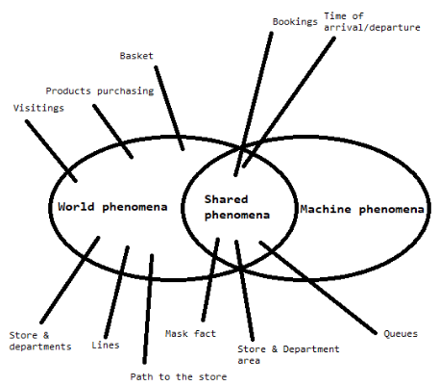

Fig 1: diagram of world phenomena & shared phenomena

**C: Definitions, Acronyms, Abbreviations**

**UML** – Unified Modeling Language.

**D: Revision History**

**E: Reference Documents**

**F: Document Structure**